**Name: VYSHNAV SURESH**

**Roll No:56**

**Batch: RMCAB**

**Date:8-6-2022**

**NETWORKING & SYSTEM ADMINISTRATION LAB**

**Experiment No.: 1**

**Aim**

Install the cmake

**1]Procedure**

**Apt show cmake**

**Output Screenshot**

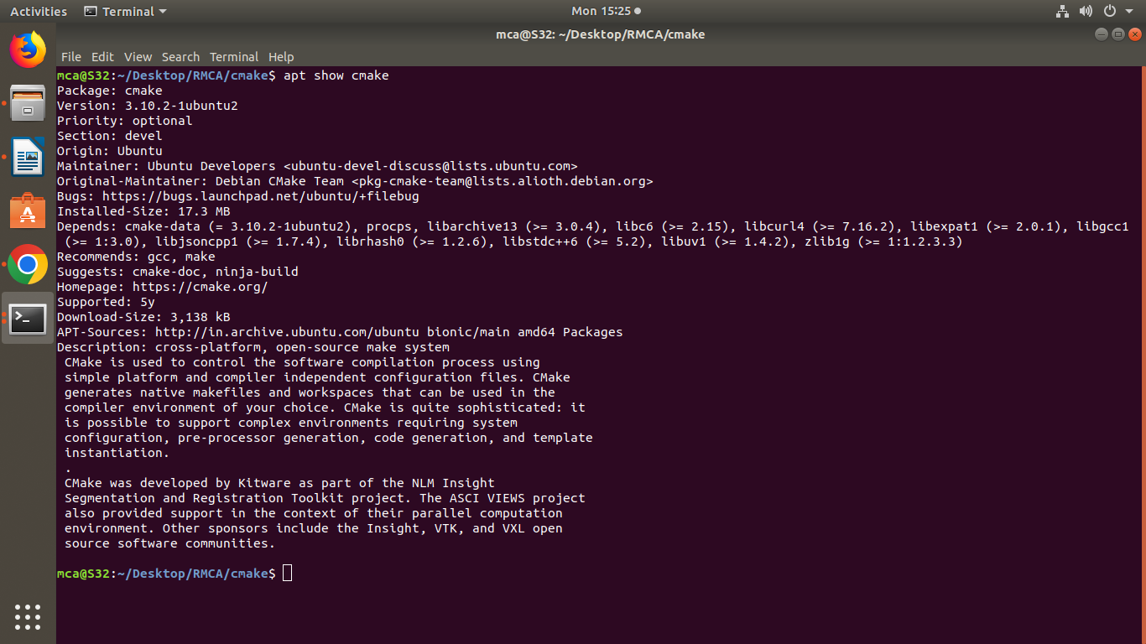

**2]Procedure**

**$sudo apt install cmake g++ make**

**Output Screenshot**

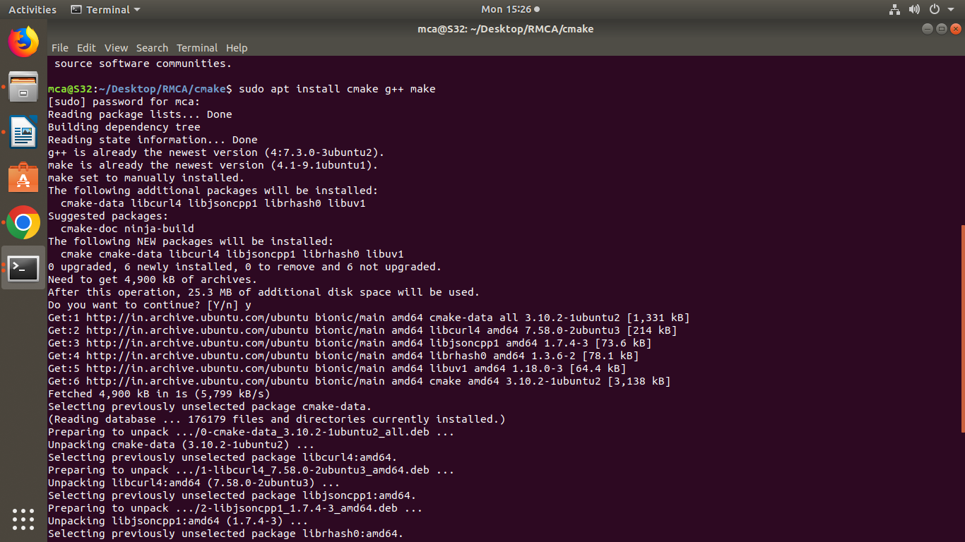

**3]Procedure**

**Create directory**

**Mkdir cmake**

**Cd cmake**

**gedit Helloworld.cpp**

**gedit CmakeLists.txt**

**Output Screenshot**

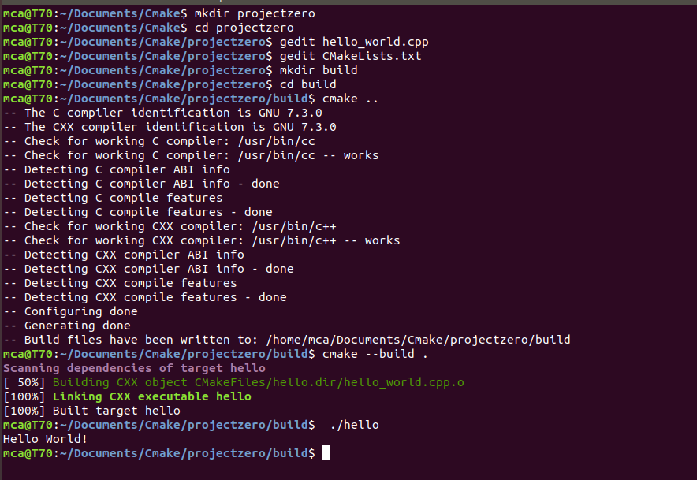

4**]Procedure**

**Create directory called**

**Mkdir build**

**Cmake ..**

**Cmake –build**

**run hello**

**./hello**

**Output Screenshot**



